SOP Risk Declaration
Aim: This SOP describes how to write a risk declaration at Sysbio. The numbered heading corresponds to the same headings in the risk declaration template.
NOTE: You are supposed to write your own risk declaration, i.e. do not copy from others!

Describe the experiment
Find the Risk Declaration template. Copy the template to your file area and fill in your name, date and the type of experiment you plan to perform. Describe the experiment. Take help from your lab buddy to write the declaration if you are a newcomer.
lifebio/LAB INFO/RISK DECLARATIONS/Risk_Declaration_Form_2.7

KLARA Risk Assessments
Log in to KLARA and find the list of ready-made risk assessments. Read all who are relevant to your experiment.
List all the risk assessments you have read, in your risk declaration.

Microorganisms
In your risk declaration, add what microorganisms you will use and their safety class. Only approved microorganisms are allowed in the laboratories.
List of approved microorganisms: Lifebio:\LAB INFO\Microorganisms\Microorganism user registers
Permission is required for taking in a new microorganism to the laboratories. When purchasing a new microorganism, fill in the form below and send to Christer Larsson. This applies also when borrowing strains between SysBio and IndBio, as the divisions are not sharing microorganisms.
Fill out the form: Lifebio:\LAB INFO\Microorganisms\Request for using a new organism in Bio

Chemicals
For safe handling of chemicals, you need to be aware of the properties and risks associated with each chemical used in your experiment.
In the table, list all chemicals you will be using in your experiments, including also all non-hazardous substances like culture media, buffers and kits. For each chemical; add all pictograms, specify the highest concentration that will be handled, and add the hazard statements (H codes).
Find hazard classifications in KLARA by clicking on the blue (i)-icon next to the chemical´s name for the pop-up information window to appear and read Material Safety Data Sheets (MSDS).

MSDS are available either in KLARA or at a chemical vendor website, e. g. Sigma-Aldrich. If you cannot find a MSDS inform the responsible research engineer who will contact the distributor.

Use of regulated chemicals
To answer the questions in section 5, look up the chemical information in KLARA for each chemical. Click on the blue (i)-icon next to the chemical´s name for the pop-up information window to appear, scroll down until all headings can be seen. If the chemical falls under certain special high-risk classifications, the headings “Regulations” and/or “Other lists” will appear in the pop-up information window.
- Restricted substances. If the heading “Regulations” shows, check if the chemical belongs to Class A (forbidden) or Class B (special permit required).
- Check if the chemical is classified as carcinogenic, mutagenic or reprotoxic, CMR. If so, it will have any of these H codes: H340, H341, H350, H351, H360, H361, H362. If it has this, you have to search for substitutions, before you start your experiment. You may get help from your supervisor, lab buddy or research engineer. There is also more info provided at LIFEBIO\LAB INFO\CHEMICALS\Registry of CMR users SYSBIO.
- Check if the chemical is classified as allergenic/sensitizing. If so, it will have the H code H317 or H334.
Note! If you have any allergies and you will be handling these substances, you are entitled to a medical examination first. Contact the research engineers for more information.

Comments on risks
State here all potential risks associated with the experiment. Risks associated with chemicals, reactions, equipment or waste handling procedures should be pointed out.

- Risk reductions
- Storage of chemicals
Specify how chemicals handled in your experiment should be stored. This is especially regarding flammables, solvents, acids and bases, and toxic chemicals.
Describe what actions are needed if you transfer a chemical to a new vessel.
Read the Chalmers routine for Storage of chemicals:
http://www.chalmers.se/insidan/EN/about-chalmers/environmental-work/policies/chemical-safety-routine/storage-labeling.
- Chemical handling
Specify how the chemicals should be handled in a risk-reducing way, e.g. volatile, corrosive and toxic chemicals should always be handled in a fume hood.
Specify what personal protection is needed for the chemicals by ticking the boxes. Write additional comments if needed.
- Cleaning and decontamination
  - Describe how biologically contaminated glassware and other labware will be handled after lab work. Specify how you plan to clean up after your experiment. If any decontamination is needed, describe how it will be done.
  - Describe how to clean and decontaminate your lab bench and other surfaces, and instruments.
- Waste handling
  - Define what kind of waste that will be accumulated in your experiments. Describe how to handle each waste type. Waste types likely to be formed are:
- agar plates
- liquid biological waste (e.g. cells in growth media)
- liquid biological waste containing chemicals and/or antibiotics
- liquid chemical waste
- solid chemical waste
- solid biological waste
  - If antibiotics are used in the experiments: add them here and describe which ones are inactivated by autoclaving and thus can be poured out the drain AFTER autoclaving, and which ones are collected as hazardous waste.
Read the Chalmers routine for Waste handling:
http://www.chalmers.se/insidan/EN/about-chalmers/environmental-work/policies/chemical-safety-routine/waste-management
Documents on waste handling and actions in case of emergency valid for our lab are found on the server.
Sysbio: on the wiki and on green information sheets in every room. A Waste guide is posted in Sysbio’s corridor.
- Final evaluation of risks
A final assessment should be prepared of the work as a whole. The matrix below should be used to help with this. If the assessment reached using the matrix is “high risk”, additional risk precautions should be taken to enable the procedure/laboratory experiment to be carried out.
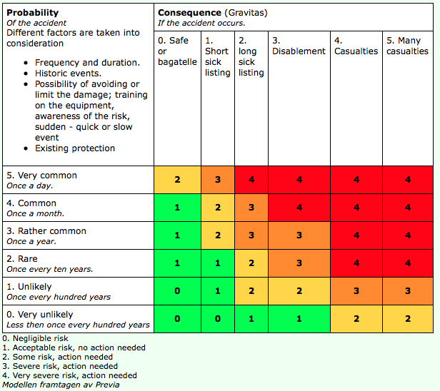
E-mail your completed Risk Declaration to your supervisor (for SysBio)
Email it to your supervisor/group leader. After her/his approval you email it to responsible research engineer. After approval it is printed, signed by you and your supervisor/group leader and then left to responsible engineer in the paper-collector above the printer in Big lab. They will then be filed.

